GUVI TASK 14

1.login into IAM user

2. to create a vpc go to vpc dashboard.

3. create new vpc

4. give ipv4 cidr block as 10.0.0.0/16

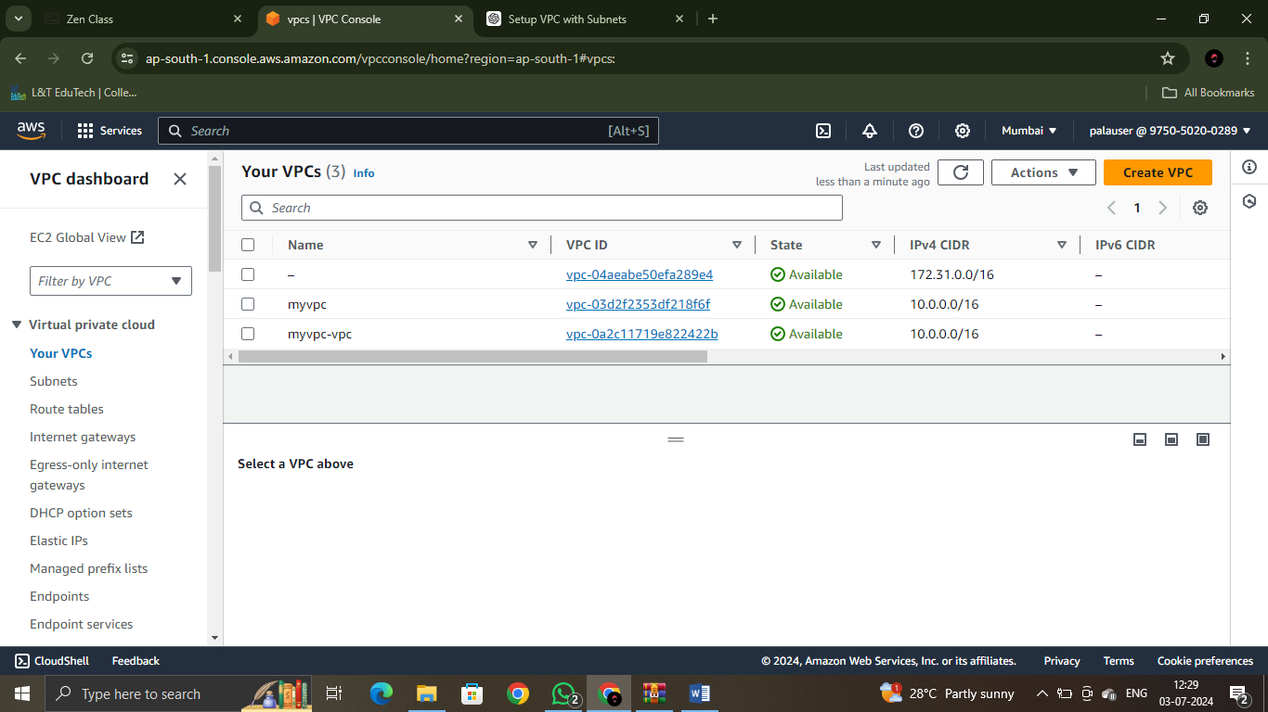

2nd one is the vpc I have created now

5.to create a internet gateway open internet gateway in left sidebar

6.create new internet gateway

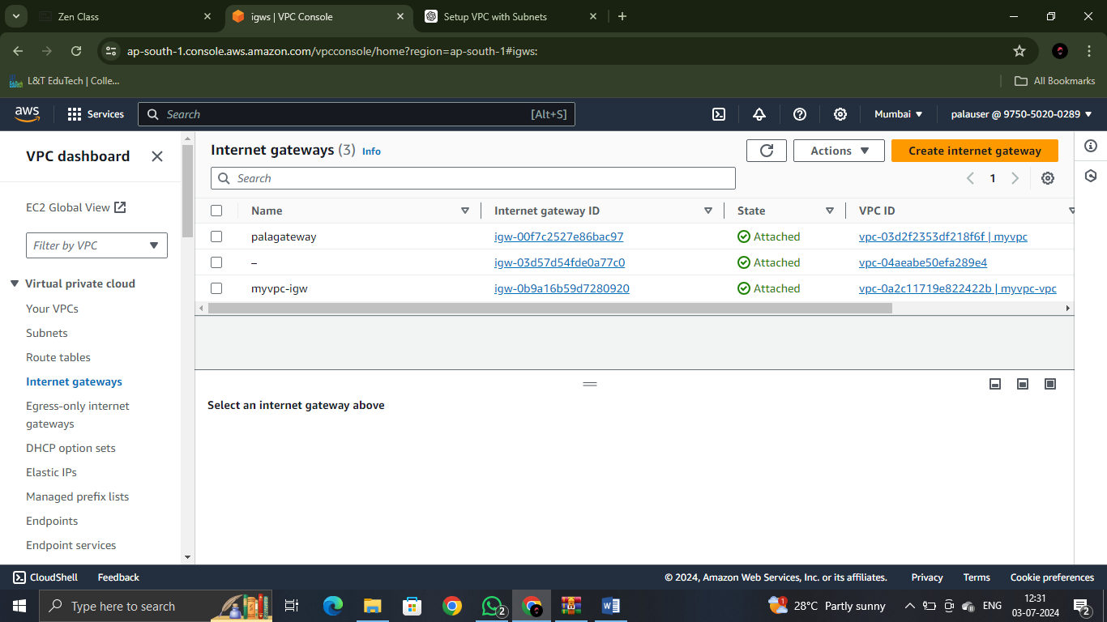

1st one is the one I have created now

7. after creating it select the gateway click actions and choose attach to vpc.

8. attach it to the vpc you have created in the previous step.

9.create a public subnet.

10.go to subnets in dashboard and create new subnet.

11. select your vpc name

12.give a subnet name

13.choose a availability zone as you wish

14.give ipv4 cidr block as 10.0.1.0/24

15.create subnet

16. same like that do for private subnet creation but cidr should be 10.0.2.0/24

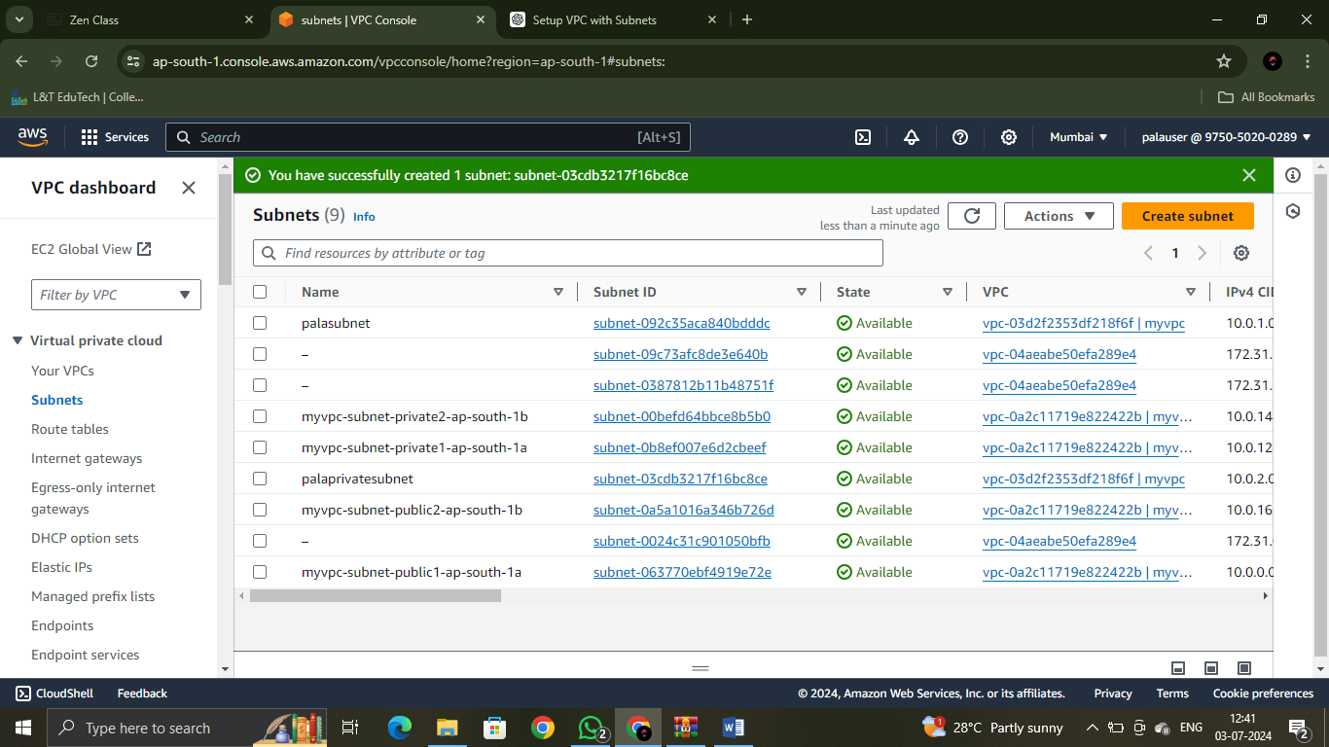

Palasubnet,palaprivatesubnet

17. now create a route table

18.give it a name

19.select your vpc you created in beginning

20.create route table

21. select the new created route table.

22.click it and edit routes

23.click add route,

Destination – 0.0.0.0/0

Target: igw-00f7c2527e86bac97(palagateway)

Igw means internet gateway

24.save routes

25. click subnet association and edit it

26. select your public subnet and save it

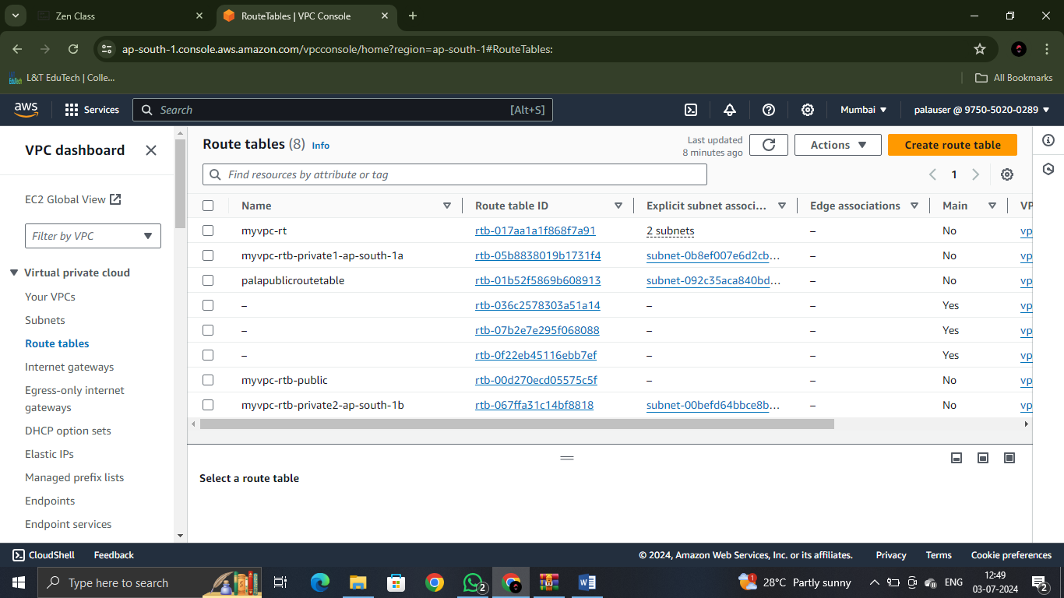

palapublicroutetable

27.now go to ec2 console and create a new ec2 instance with a name and select AMI as amazon linux

28. give a key pair

29. t2micro

30.click edit network settings and select your vpc you created in the beginning.

31.select the subnet also

32.ensure auto assign public ip is enabled

33.ensure security group settings allow ssh traffic

34.launch the new instance

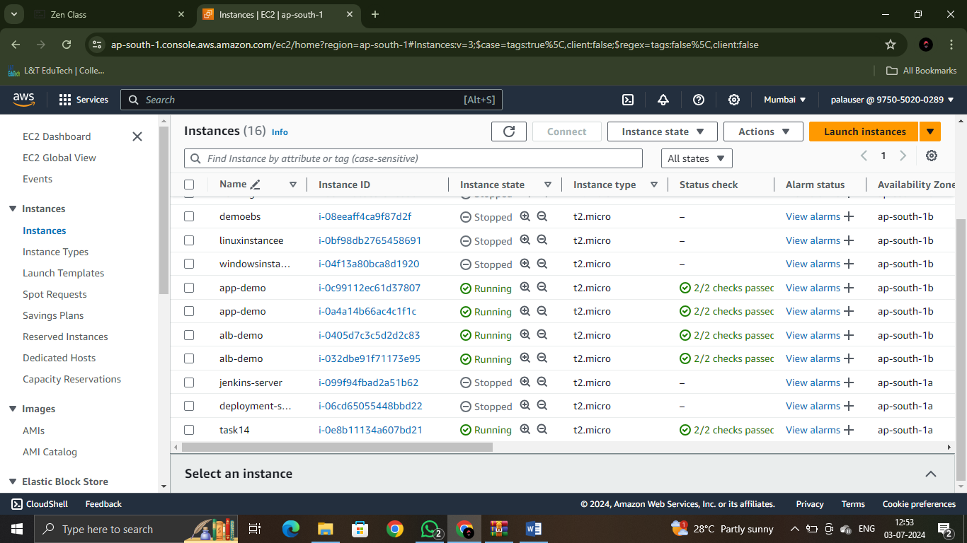

-----X-----